**Capstone Project**

**Weather Analysis**



**Sheik Fiyaz S I**

**Data Analyst**

**Overview:**

The Comprehensive Weather Analysis Capstone Project is a multifaceted endeavor that aims to gain deep insights into various meteorological factors impacting a specific geographic area. This project leverages a rich dataset spanning five years, encompassing high temporal resolution data on essential weather attributes such as humidity, pressure, temperature, weather descriptions, wind direction, and wind speed. The primary objective is to extract valuable information from this dataset to support informed decision-making for various stakeholders, including government agencies, businesses, and individuals.

The project systematically addresses six key aspects of weather analysis, each offering unique insights into the dynamics of local weather conditions. These aspects include humidity analysis, pressure analysis, temperature analysis, weather description analysis, wind direction analysis, and wind speed analysis.

The project's goals encompass multiple dimensions, including identifying long-term trends and seasonal variations in temperature and humidity, analyzing atmospheric pressure patterns to enhance weather forecasting, categorizing and analyzing weather descriptions to understand weather conditions, and assessing wind direction and speed patterns to support industries like renewable energy and aviation.

Weather analysis is a dynamic and ever-changing field, and this project aims to provide the tools and knowledge necessary to navigate it effectively and make informed decisions for a more sustainable future**.**

**Capstone Project: Weather Analysis**

**1**

**Process:**

**Data Transformation and Enhancement**

*(MS Excel, Csved)*

**Data Acquisition**

*(GitHub and Kaggle)*

**Approaching MECE analysis**

*(Power Point)*

**Connection with Tools**

*(PowerBI, MS Excel, MySQL Workbench)*

**Approaching Problem Statement in PowerBI and Exploratory Data Analysis and Dashboard**

*(City Attributes, Temperature, Humidity & weather description and Wind Attributes analysis)*

**Detailed Documentation**

*(Compilation of all works carried out to perform analysis under this project lifecycle)*

**Creating Visual and Insightful Reports**

*(MS PowerPoint, Canva and Slides Go)*

**2**

**Capstone Project: Weather Analysis**

**Objectives:**

Through the Comprehensive Weather Analysis Capstone Project, we aim to delve deep into the intricate world of meteorological data to uncover valuable insights and trends, enabling data-driven decision-making and informed responses to the ever-changing weather conditions. The objectives of this project signify:

* **Data Exploration:** To explore and understand the provided weather dataset, including city attributes, temperature, humidity, weather descriptions, wind speed, and wind direction.
* **Insight Generation:** To extract meaningful insights from the data that can be used for various purposes, including weather forecasting, urban planning, and energy management.
* **Visual Representation:** To create informative visualizations in Power BI to effectively communicate the findings from the analysis to stakeholders.

**In-Depth Insights:** The primary objective of the Comprehensive Weather Analysis Capstone Project is to gain in-depth insights into various meteorological factors affecting a specific geographic area. By systematically analyzing data on humidity, pressure, temperature, weather descriptions, wind direction, and wind speed, this project aims to uncover meaningful patterns and trends.

**Seasonal Variations:** This project seeks to identify and understand seasonal variations in weather attributes, allowing stakeholders to prepare for and respond to seasonal changes effectively. The analysis will provide information on temperature shifts, humidity patterns, and weather condition variations across different seasons.

**Correlations and Trends:** A key objective is to uncover correlations between different weather attributes and their impact on various aspects of daily life. By examining how weather conditions relate to phenomena like wildfire spread, this project will reveal valuable insights.

**Data-Driven Decision-Making:** The project aims to provide data-driven recommendations and insights that can be used by a wide range of stakeholders, including government agencies, businesses, and the general public. These insights can inform decisions related to agriculture, energy management, transportation, urban planning, and emergency preparedness.

**3**

**Capstone Project: Weather Analysis**

**Significance:**

The significance of the Comprehensive Weather Analysis Capstone Project lies in its potential to impact numerous facets of our lives, from enhancing public safety and resource management to contributing to climate change mitigation. By harnessing the power of weather data, this project offers practical applications and data-driven solutions that can benefit individuals, businesses, and government agencies alike.

Practical Application: Weather profoundly influences daily life, impacting agriculture, energy consumption, transportation, and various industries. This project equips stakeholders with practical tools and knowledge to harness weather data for better planning and resource management.

Improved Resource Management: By understanding weather patterns, businesses and government agencies can optimize resource allocation. For example, agriculture can benefit from weather-related planting and harvesting schedules, while the energy sector can use wind speed and direction analysis to optimize wind energy generation.

Disaster Preparedness: Weather analysis is essential for disaster preparedness. Government agencies can use the insights from this project to develop more effective disaster response plans, ensuring the safety and well-being of communities during extreme weather events.

Climate Change Mitigation: Climate change has a profound impact on weather patterns. By studying historical weather data, we can contribute to a better understanding of climate change and its effects, leading to more effective climate mitigation strategies.

Informed Decision-Making: The project promotes informed decision-making at various levels. Government agencies can make data-driven policy decisions, businesses can optimize operations, and the public can plan their daily activities more effectively based on accurate weather information.

**4**

**Capstone Project: Weather Analysis**

**Data Dictionary: * used in power BI**

**city attributes**

Country_id 🡺 Foreign key referencing Country_id in country table

City_id 🡺 Foreign key referencing City_id in city_lookup table

Latitude 🡺 Specifies latitude coordinates of a city.

Longitude 🡺Specifies longitudinal coordinates of a city.

Country_id, City_id, Latitude and Longitude

**country**

Country_id 🡺 Unique identifier for each country located in dataset.

Country 🡺 Specifies the country name.

Country_id and Country

**city_lookup**

City_id 🡺 Unique identifier for each city located in dataset.

Country 🡺 Specifies name of the city.

City_id and City

**date_lookup**

date_id 🡺 Unique identifier for date in dataset.

date 🡺 Specifies the date in d%: m%: Y%.

season_id 🡺 Foreign key referencing season_id in season_lookup table.

date_id and date,

season_id and season *

**time_lookup**

time_id 🡺 Unique identifier for time in dataset.

time 🡺 Specifies the time in H%: m%: s%.

time_id and time

**final_fact**

City_id 🡺 Foreign key referencing City_id in city_lookup table

date_id 🡺 Foreign key referencing date_id in date_lookup table.

time_id 🡺 Foreign key referencing time_id in time_lookup table.

humidity 🡺 Specifies relative humidity in %.

pressure 🡺Specifies pressure in millibars or hectopascals.

temperature 🡺Specifies temperature in Kelvin.

weather_description 🡺 Specifies weather condition.

wind_direction 🡺 Specifies wind flow direction in Degree (°).

wind_speed 🡺 Specifies wind speed in Knots.

Longitude 🡺Specifies longitudinal coordinates of a city.

City_id, date_id, time_id, humidity, pressure, temperature, weather_description, wind_direction and wind_speed

**season_lookup\***

season_id 🡺 Unique identifier for each season in dataset.

Season 🡺 Specifies name of the season.

season_id and season

**5**

**Capstone Project: Weather Analysis**

**ER Diagram:**

**Capstone Project: Weather Analysis**

**6**

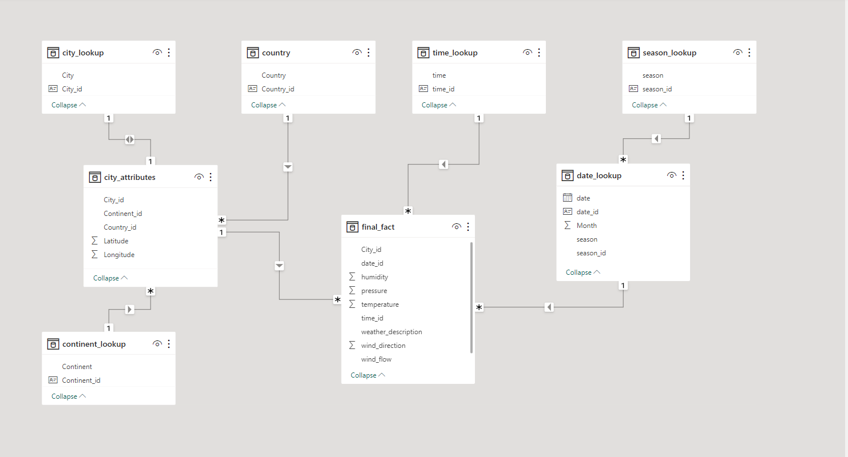

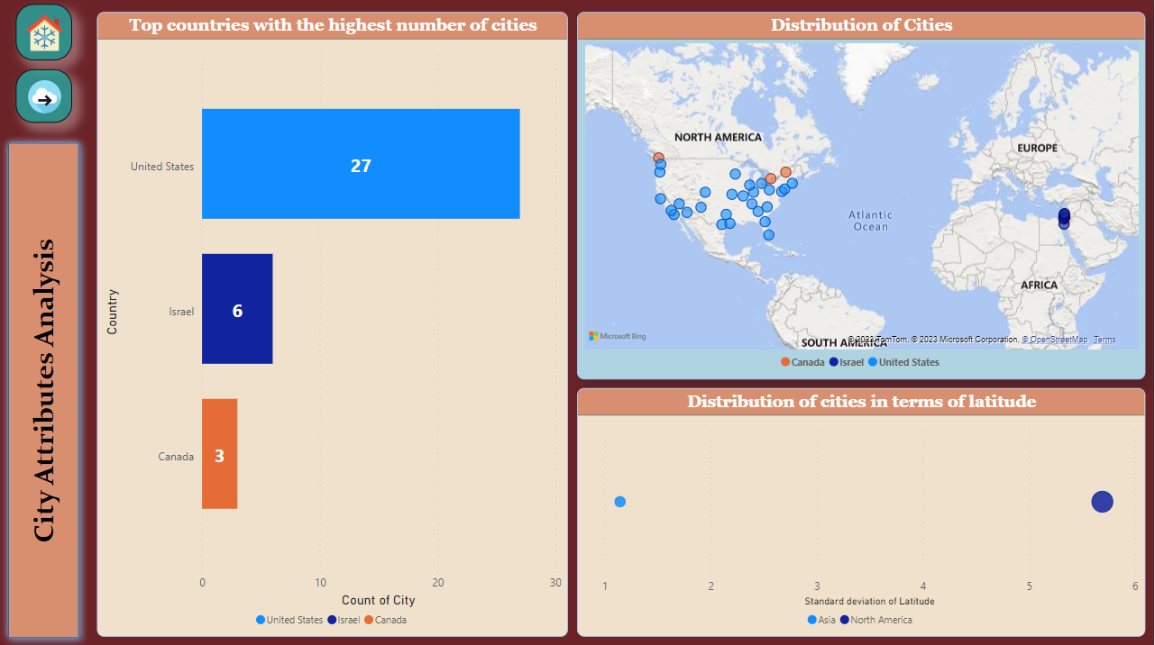**PowerBI Problem Statements:**

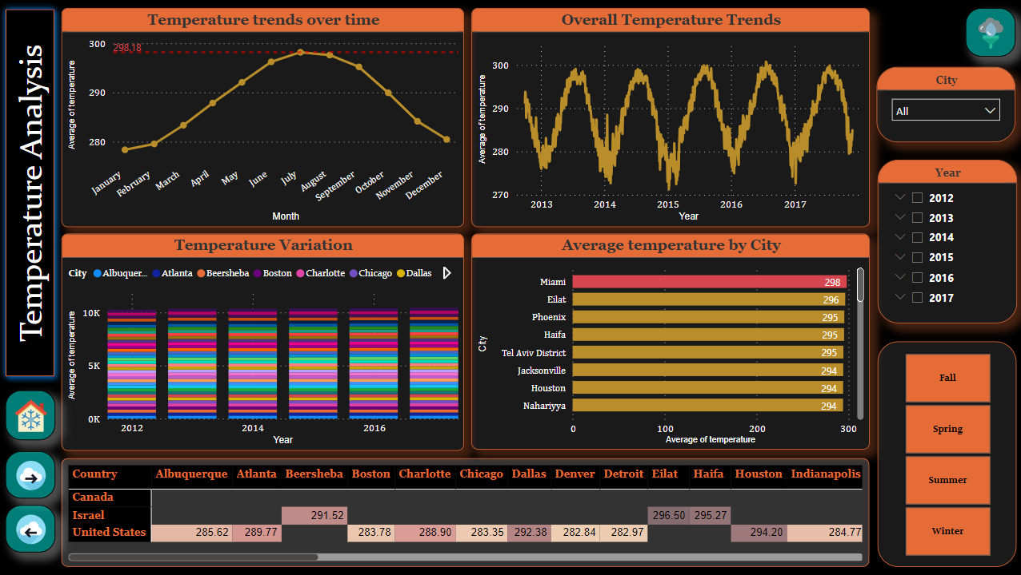

**7**

**Capstone Project: Weather Analysis**

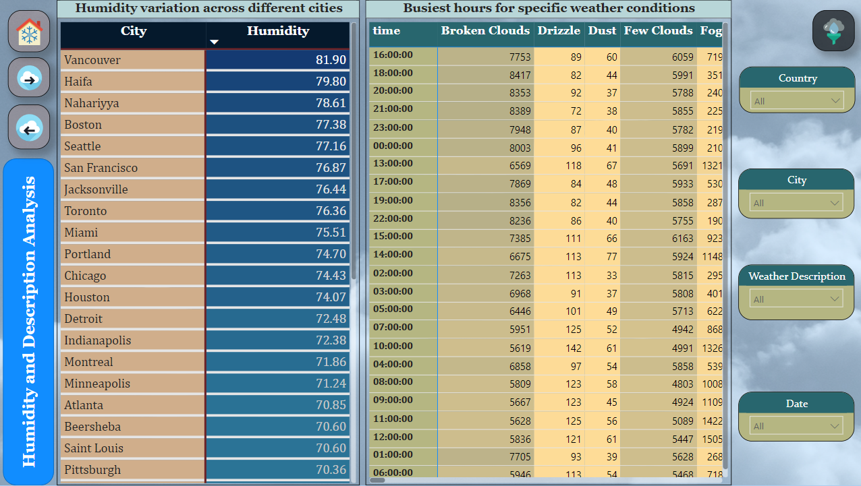

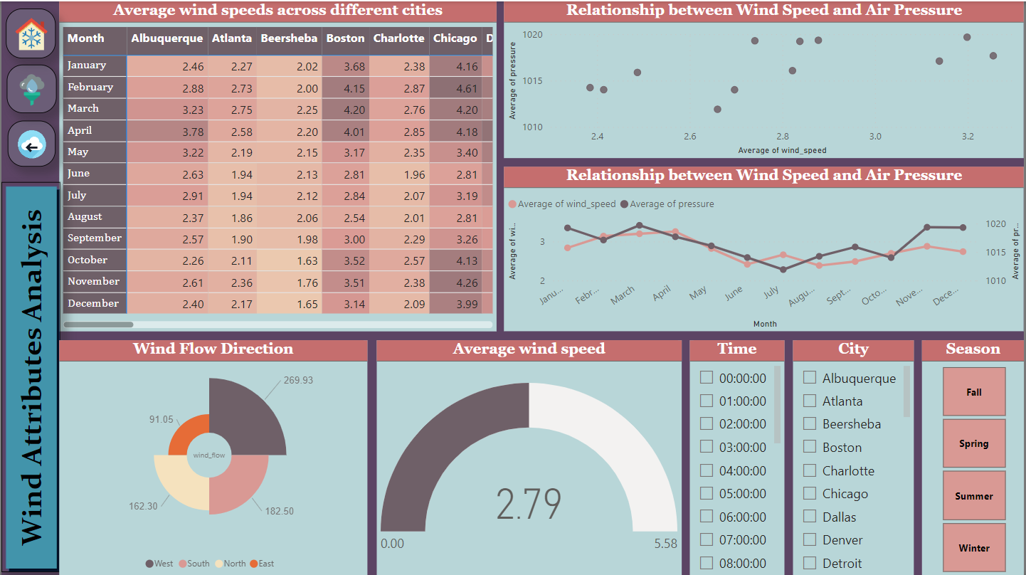

**Capstone Project: Weather Analysis**

**8**

**Can you create a geographical map in Power BI showing the distribution of cities in the dataset based on their latitude and longitud**e?

Yes. Creating a geographical map in Power BI to display the distribution of cities based on their latitude and longitude is possible. The dataset provides city coordinates, including latitude and longitude, which can be utilized to generate an interactive map. This map visualization offers insights into the geographic spread of cities, enhancing our understanding of their distribution and there are 27 cities in United States, 3 cities in Canada sand 6 cities in Israel.

**In Power BI, can you create a bar chart representing the top 10 countries with the highest number of cities in the dataset?**

Certainly, a bar chart can be generated in Power BI to visually depict the top 10 countries with the highest number of cities within the dataset. This visualization offers a clear comparison of countries with the most cities, providing valuable insights into the distribution of cities across different regions. It's worth noting that the dataset provided contains data for three countries. The United States has 27 cities, Israel has 6 cities and Canada has 3 cities in this dataset.

**How does the distribution of cities in terms of latitude vary across different continents? Create a scatter plot in Power BI to illustrate this.**

The scatter plot created in Power BI illustrates how the distribution of cities in terms of latitude varies across different continents. The plot allows for a visual comparison of the latitudinal positioning of cities across various continents, providing insights into geographical variations in city distribution. This analysis interprets the countries in Asia (6 cities) and North America (30 cities) distribution of cities which has standard deviation of 1.15 and 5.69 respectively.

**Capstone Project: Weather Analysis**

**9**

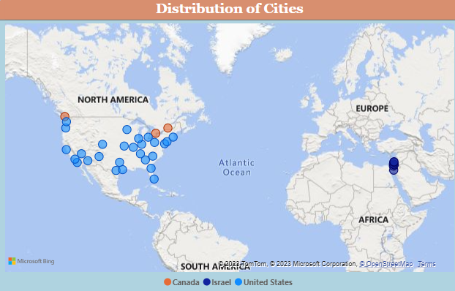

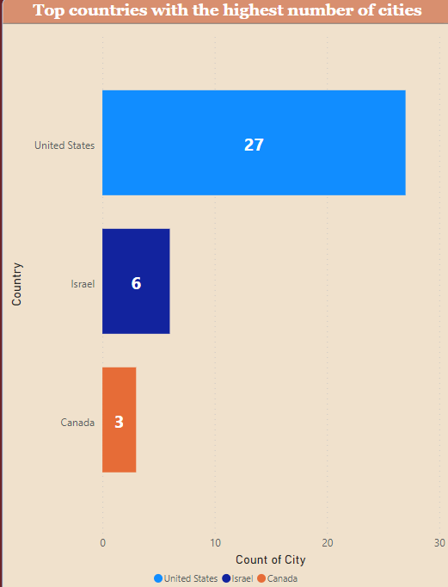

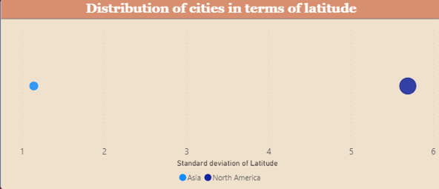

**Capstone Project: Weather Analysis**

**10**

**Create a line chart in Power BI to display the temperature trends over time for a selected city. Highlight extreme temperature events**.

In response to the question, a line chart has been generated in Power BI to visualize temperature trends over time for a specific city. This line chart not only allows us to observe the temperature variations but also serves the purpose of highlighting extreme temperature events. It's worth noting that the higher extreme average temperature in the dataset is 298.18 K. This feature of the chart makes it easier to identify and analyze periods of significant temperature fluctuations, enhancing our ability to track temperature changes and detect extreme weather conditions efficiently.

**Create a time-series line chart in Power BI to show the overall temperature trends over the entire dataset**

A time-series line chart has been successfully constructed in Power BI to track temperature trends over various years. The chart displays a ‘wavy’ pattern, a common trait of the inherent variations in temperature over time. This pattern could signify seasonal shifts, cyclical temperature trends, or enduring climate changes. Examination of this wavy pattern can offer insights into the mechanics of temperature, recurring temperature events, or irregularities. These insights have potential applications in diverse fields such as climate studies and energy management.

**Create a Power BI chart comparing the temperature variations between two selected cities over a specific timeframe**

A chart has been successfully created in Power BI to facilitate the comparison of temperature variations between two selected cities over a specific timeframe. This chart allows users to interactively choose and visualize data for their preferred cities by using a slicer, enhancing the flexibility and depth of temperature trend analysis. The slicer feature enables users to dynamically explore and compare temperature patterns, making it a powerful tool for gaining insights into how temperature trends differ between the selected cities.

**Capstone Project: Weather Analysis**

**11**

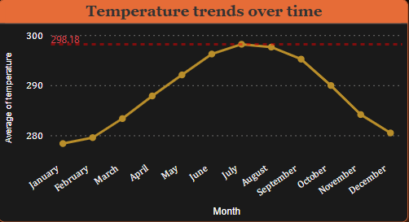

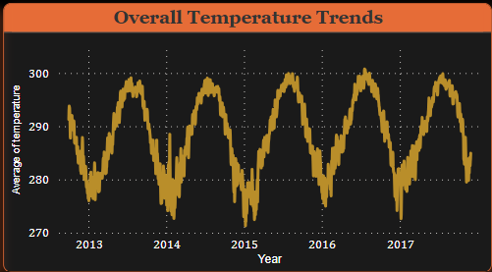

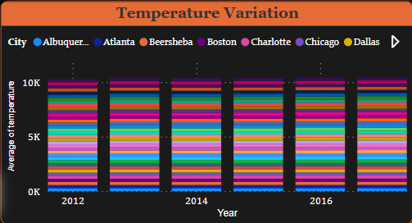

**12**

**Capstone Project: Weather Analysis**

**Can you build a heatmap in Power BI to show the temperature ranges for cities across different countries**?

Yes. The heatmap has been successfully created in Power BI to depict temperature ranges for cities across different countries. This visual representation offers a clear and insightful view of how temperatures vary across various geographic locations. It is a valuable tool for data analysis and decision-making, particularly in understanding temperature patterns and trends across multiple countries and cities in our dataset. Interpreting the Data were Miami, US has been recorded highest average temperature (298.18 K) and Montreal, Canada has been recorded lowest average temperature (280.34 K).

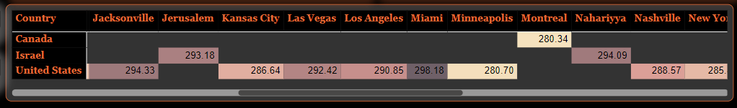

**Create a bar chart in Power BI to highlight cities with the highest and lowest average temperatures in the dataset**.

The bar chart has been successfully created in Power BI to highlight cities with both the highest and lowest average temperatures in the dataset. Interpreting the Data were Miami, US has been recorded highest average temperature (298.18 K) and Montreal, Canada has been recorded lowest average temperature (280.34 K). This visualization offers a straightforward and effective means of identifying temperature extremes among the cities in our dataset. It can aid in pinpointing locations with notably hot or cold climates, providing valuable insights for various applications, from weather analysis to urban planning and resource allocation.

**13**

**Capstone Project: Weather Analysis**

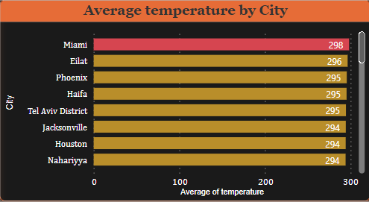

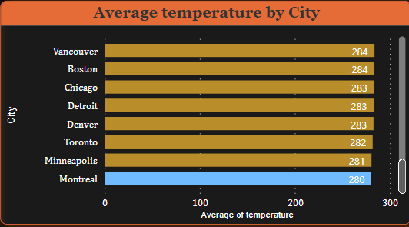

**14**

**Capstone Project: Weather Analysis**

**How does humidity vary across different cities? Generate a heatmap in Power BI to visualize this variation**.

Yes, Humidity levels across different cities can be effectively visualized using a heatmap in Power BI. This heatmap offers a graphical representation of how humidity varies across various cities, helping to identify patterns and variations in humidity levels. It provides a comprehensive overview of humidity distribution and facilitates the comparison of humidity trends across different geographic locations. This visual representation is instrumental in understanding the spatial differences in humidity and is valuable for applications such as climate analysis and urban planning. Interpreting the data Vancouver has the highest amount of average humidity (8.90%) and whereas the Las Vegas has the lowest amount of average Humidity (31.94%)

**Can you create a heatmap in Power BI to visualize the busiest hours for specific weather conditions (e.g., "clear sky," "rainy")?**

Yes, Power BI enables the creation of a heatmap to visually represent the busiest hours for specific weather conditions like 'clear sky' and 'rainy.' This heatmap serves as a graphical tool that illustrates how these weather conditions are distributed throughout the day, allowing us to pinpoint the peak hours when they are most prevalent. To identify these busiest hours, we can apply filters to count the occurrences of weather descriptions and sort them by values, associating the time when the descriptions are most relevant. This analytical approach provides valuable insights into the temporal patterns of various weather conditions and holds practical utility in applications like weather forecasting and event planning

**15**

**Capstone Project: Weather Analysis**

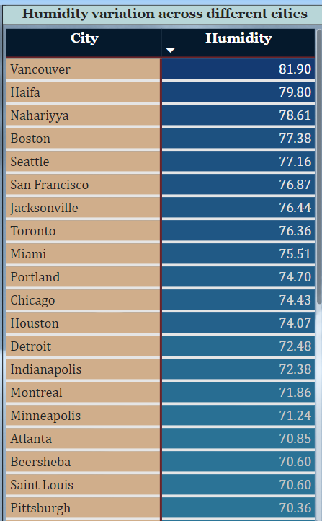

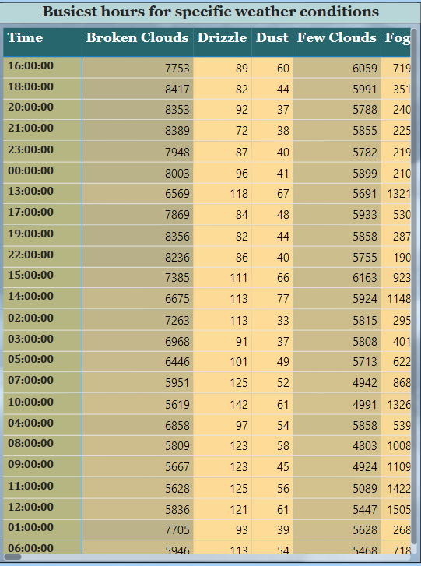

**Capstone Project: Weather Analysis**

**16**

**Can you create a time-series chart in Power BI showing the relationship between wind speed and air pressure for a specific city?**

Yes, in Power BI, it's possible to create a time-series chart to display the relationship between wind speed and air pressure for a specific city. This chart would help visualize the dynamics and correlations between these two weather attributes over time, facilitating a better understanding of how wind speed and air pressure interact within the chosen city. This analysis can provide insights into weather patterns and events specific to that location, making it valuable for meteorological studies and weather-related decision-making.

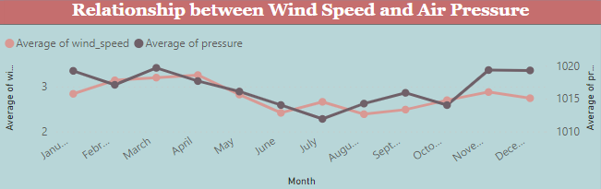

**Create a Power BI scatter plot to show the relationship between wind speed and air pressure for a specific city.**

In Power BI, a scatter plot can be created to display the relationship between wind speed and air pressure for a specific city. This scatter plot visualizes how these two weather attributes correlate, allowing us to identify patterns, trends, or potential dependencies between wind speed and air pressure in the chosen city. Such analyses are essential for understanding local weather dynamics and can be valuable for a range of applications, including weather forecasting and environmental monitoring.

**17**

**Capstone Project: Weather Analysis**

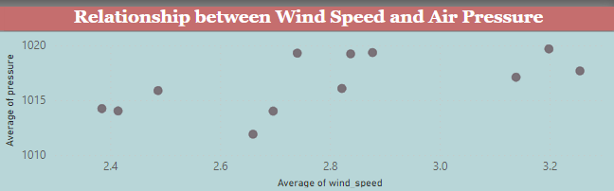

**Can you generate a Power BI heatmap illustrating the average wind speeds across cities for different months of the year?**

Yes, in Power BI, you can generate a heatmap to illustrate the average wind speeds across cities for different months of the year. This heatmap provides a visual representation of how average wind speeds vary across various cities over the course of the year. It's a valuable tool for understanding seasonal changes in wind patterns and can be useful for applications such as weather forecasting, energy production planning, and environmental impact assessments.

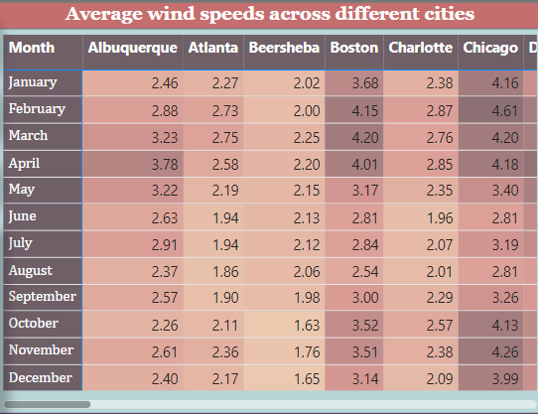

**Capstone Project: Weather Analysis**

**18**

**How does the wind speed change over the course of a day? Create a radial chart in Power BI to represent** this.

To understand how wind speed changes over the course of a day, a radial chart can be generated in Power BI to illustrate this variation. A radial chart provides an effective way to visualize the cyclic patterns of wind speed throughout the day, allowing us to identify fluctuations and trends in a clear and concise manner. This type of chart is particularly useful for observing diurnal variations in wind speed, which can have important implications for various applications, including renewable energy planning, safety measures, and outdoor activities.

**Create a wind rose chart in Power BI to visualize the prevailing wind directions for a selected city.**

In Power BI, it is possible to create a wind rose chart to visually represent the prevailing wind directions for a selected city. A wind rose chart is a specialized chart type that displays the distribution and frequency of wind directions, making it an excellent tool for understanding the dominant wind patterns in a specific location. This visualization helps meteorologists, environmental scientists, and urban planners gain insights into the local wind climate, which is valuable for various applications, including air quality monitoring, renewable energy assessment, and urban design.

**Capstone Project: Weather Analysis**

**19**

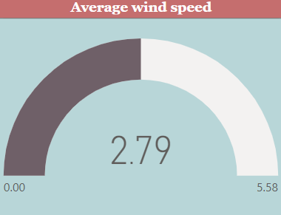

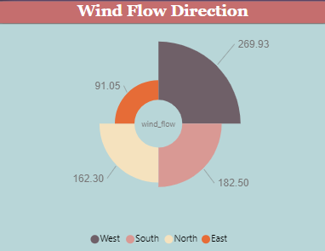

**Capstone Project: Weather Analysis**

**20**

**EDA Problem Statements:**

**Are there any countries with cities located at extreme latitudes, and how might this impact their climate?**

There are no city lies in the extreme latitude that is beyond 60°N and 60° S in the given dataset. So alternative analysis was carried out.

**Mention countries with cities located at Highest and Lowest latitudes, how might this impact their climate?**

Northern Extreme Latitudes: Vancouver, Canada located in the Northern Hemisphere, particularly 49.24966 °N latitude.

* Colder Winters: Cities at extreme northern latitudes tend to have colder winters with shorter daylight hours, leading to colder temperatures, snowfall, and ice.
* Seasonal Variation: There can be a significant seasonal temperature variation, with warm summers and cold winters. This seasonal variation can impact agriculture, outdoor activities, and infrastructure maintenance.
* Daylight Duration: At higher latitudes, there can be significant variations in the duration of daylight throughout the year. In extreme cases, there may be periods of 24-hour daylight in the summer and 24-hour darkness in the winter.
* Challenges for Agriculture: Colder climates and shorter growing seasons can pose challenges for agriculture, impacting the types of crops that can be grown and the availability of fresh produce.

Southern Extreme Latitude: Miami, United States located in the Northern Hemisphere, particularly 25.774269 °N latitude.

* Warmer Climate: Cities at extreme southern latitudes tend to experience warmer climates, with milder winters and hot summers.
* Limited Seasonal Variation: There is generally less seasonal temperature variation in cities at extreme southern latitudes compared to those at extreme northern latitudes.
* Tourism: Warmer climates can make these regions attractive for tourism, particularly during the winter months when people from colder regions seek milder weather.

**Capstone Project: Weather Analysis**

**21**

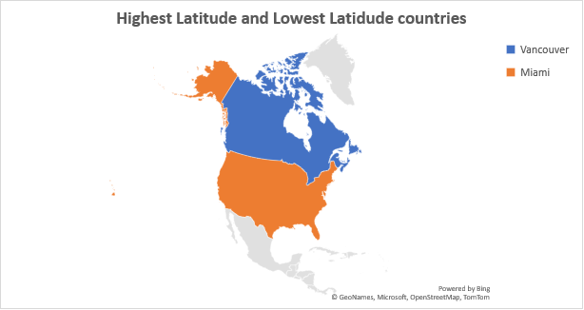

Output: 

**Can you identify any clusters of cities with similar latitude and longitude values? What factors might explain these clusters?**

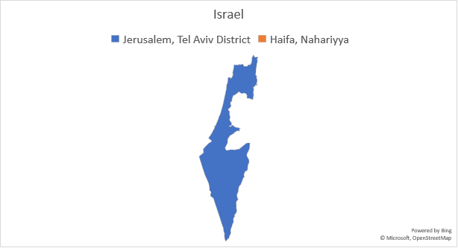

**Capstone Project: Weather Analysis**

**22**

Output:

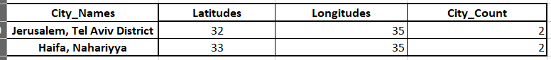

Jerusalem & Tel Aviv District and Haifa & Nahariyya are two cluster of cities with similar latitude and longitude values.

* Geographic Features: Cities in close proximity may share similar geographic features, such as being located near mountains, rivers, or coastlines.
* Climate Patterns: Cities with similar latitudes and longitudes may experience similar climate patterns, including temperature ranges, precipitation levels, and seasonal variations.
* Historical Settlements: Historical factors can influence the clustering of cities. For example, cities with similar coordinates may have been established for similar reasons, like trade or defense.
* Geographical Proximity: Cities that are close to each other may cluster due to their proximity, leading to shared economic, cultural, or social ties.
* Regional Development: Cities within the same cluster may have experienced similar patterns of economic or industrial development, leading to similar infrastructure and characteristics.
* Topography and Elevation: Cities in clusters may share similar elevation levels or topographical features, which can impact local climate and agriculture.
* Administrative or Political Boundaries: Clusters could also be related to administrative or political boundaries, as countries or states often group cities together for governance purposes.

**Capstone Project: Weather Analysis**

**23**

**Are there any correlations between a city's geographical location (latitude and longitude) and its weather attributes, such as temperature or humidity?**

Latitude and Temperature (-0.167):

* The correlation coefficient between latitude and temperature is approximately -0.167, indicating a weak negative relationship.
* This suggests that as you move further north (towards higher latitudes), there is a slight tendency for the temperature to decrease. However, the correlation is not strong, and latitude alone does not explain a significant portion of the variation in temperature.

Longitude and Temperature (0.027):

* The correlation coefficient between longitude and temperature is approximately 0.027, indicating a weak positive relationship.
* This implies that there is a slight tendency for the temperature to increase as you move east (towards higher longitudes). However, similar to latitude-temperature correlation, this relationship is not strong.

Latitude and Humidity (0.102):

* The correlation coefficient between latitude and humidity is approximately 0.102, indicating a weak positive relationship.
* This suggests that humidity tends to be slightly higher in cities located further north (higher latitudes). Again, the correlation is not very strong, and other factors likely have a more significant influence on humidity.

Longitude and Humidity (0.059):

* The correlation coefficient between longitude and humidity is approximately 0.059, indicating a weak positive relationship.
* Similar to latitude and humidity, there is a slight tendency for humidity to increase as you move east (higher longitudes). However, this relationship is not strong.
* These correlations, while statistically significant, are relatively weak, meaning that latitude and longitude alone do not provide a strong basis for predicting temperature and humidity. It's important to recognize that weather patterns are influenced by various complex factors beyond geographical location, such as topography, local climate, and atmospheric conditions. These correlations should be considered as one piece of the puzzle when analyzing weather data for cities.

**Capstone Project: Weather Analysis**

**24**

Output:

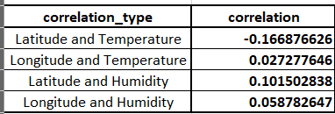

**Identify the top three cities with the most frequent occurrence of rainy weather based on weather descriptions. What are the seasonal patterns?**

Output:



**Capstone Project: Weather Analysis**

**25**

* The analysis of weather data revealed that Seattle, Washington, experienced the highest number of rainy days among all cities in the dataset, with a total of 11,369 rainy days. Portland, Oregon, closely followed with 11,033 rainy days, making it the second city with a high frequency of rainy weather. Vancouver, another city in the Pacific Northwest, also had a significant number of rainy days, totaling 10,417.
* These findings indicate that cities in the Pacific Northwest region of the United States and Canada are particularly prone to rainy weather conditions. This could be attributed to the geographical location and climate patterns of the region, which are characterized by a high frequency of precipitation.
* To understand the seasonal patterns of rainy weather in these cities, further analysis can be conducted by grouping the data by seasons and exploring how the frequency of rainy weather varies throughout the year. This analysis may provide insights into the specific seasons during which these cities experience the highest and lowest occurrences of rainy weather.

**Capstone Project: Weather Analysis**

**26**

**Is there a correlation between humidity levels and air pressure? How might this relationship affect weather conditions?**

* The analysis of weather data revealed that Seattle, Washington, experienced the highest number of rainy days among all cities in the dataset, with a total of 11,369 rainy days. Portland, Oregon, closely followed with 11,033 rainy days, making it the second city with a high frequency of rainy weather. Vancouver, another city in the Pacific Northwest, also had a significant number of rainy days, totaling 10,417.
* These findings indicate that cities in the Pacific Northwest region of the United States and Canada are particularly prone to rainy weather conditions. This could be attributed to the geographical location and climate patterns of the region, which are characterized by a high frequency of precipitation.
* To understand the seasonal patterns of rainy weather in these cities, further analysis can be conducted by grouping the data by seasons and exploring how the frequency of rainy weather varies throughout the year. This analysis may provide insights into the specific seasons during which these cities experience the highest and lowest occurrences of rainy weather.



Output:

**Capstone Project: Weather Analysis**

**27**

**Explore the impact of wind direction on temperature for coastal cities. Are there noticeable patterns?**

* In exploring the impact of wind direction on temperature for coastal cities, we observe the following patterns:
* Positive Correlation in Some Cities:
* Portland, Los Angeles, and San Diego exhibit a positive correlation between wind direction and temperature. This suggests that as wind direction changes, temperatures in these cities tend to increase. These cities may experience warmer temperatures with specific wind directions.
* Neutral or Negative Correlation in Other Cities:
* Several other coastal cities either show a neutral (close to zero) correlation or a negative correlation between wind direction and temperature. This implies that there is little to no significant relationship between wind direction and temperature in these cities.
* Missing Data:
* For some coastal cities such as Vancouver, San Francisco, Beersheba, Tel Aviv District, Eilat, Haifa, Nahariyya, and Jerusalem, the correlation between wind direction and temperature could not be calculated due to missing data.
* These patterns suggest that the impact of wind direction on temperature varies among coastal cities. Some cities show a notable relationship, while others do not exhibit strong correlations. It is essential to consider local geographic and meteorological factors that may influence these patterns.

Output:

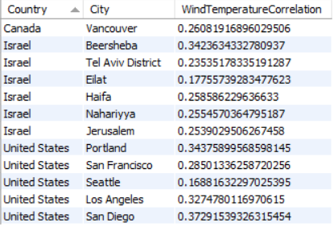



**28**

**Are there specific months when cities experience significant temperature fluctuations? What might explain these variations?**

Explanation:

In the dataset, several cities experience significant temperature fluctuations during specific months. For instance, 'Kansas City' shows the highest temperature fluctuations, with a notable deviation in temperature from January to August, reflecting the desert climate of the region. 'San Francisco' and 'Eilat' also exhibit some fluctuations, while cities like 'Atlanta' and 'Los Angeles' maintain relatively stable temperatures throughout the year due to their respective coastal and warm climates.

These variations can be attributed to various factors such as geographical location, climate type, and seasonal transitions. For example, cities in colder climates, like 'Minneapolis,' experience significant fluctuations as they transition from winter to spring, with temperatures rising from January to May.

Conversely, cities in warmer regions like 'Phoenix' and 'Eilat' show more stability in their temperatures throughout the year. Geographical features like proximity to bodies of water, mountains, or deserts can also influence temperature fluctuations. Understanding these patterns is crucial for predicting and preparing for weather-related challenges in different regions.

**Capstone Project: Weather Analysis**

**29**

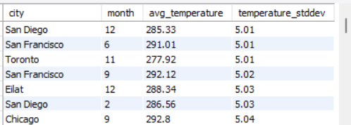

Output:

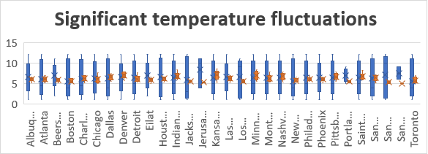

**Identify periods of extreme weather events, such as storms or heatwaves, by analyzing the time-based data. What patterns emerge?**

In Heatwave analysis, the Beersheba and Elliat from Israel shows the maximum level of value from the threshold.

Emerging Patterns:

 The patterns that may emerge from this analysis can include:

 Seasonality: Identifying specific seasons or months when extreme events are more likely to occur.

Regional Variations: Recognizing that some areas are more prone to certain types of extreme weather events.

Climate Change Trends: Detecting potential shifts in the frequency and intensity of these events over time, which may be indicative of climate change.

Health and Safety Impacts: Understanding the impact of these events on human health, infrastructure, and safety

**Capstone Project: Weather Analysis**

**30**

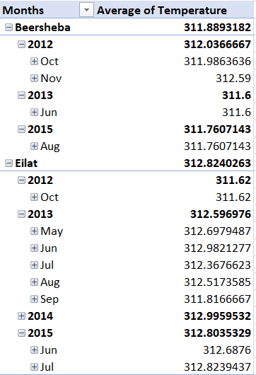

Output:

**31**

**Capstone Project: Weather Analysis**

**Are there any notable differences in temperature trends between northern and southern hemisphere cities over the year? How do they relate to seasons:**

No, In this dataset, there are no cities located in the Southern Hemisphere. As a result, we are unable to perform a comparative analysis of temperature trends between Northern and Southern Hemisphere cities or relate them to seasons. The analysis is limited to Northern Hemisphere cities only. If data from Southern Hemisphere cities becomes available in the future, a more comprehensive analysis can be conducted to explore temperature trends in both hemispheres.

**Show the Average Seasonal temperature trends across the countries**

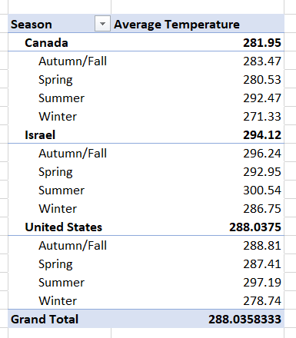

Output:

**Capstone Project: Weather Analysis**

**32**

The table presents the average temperatures in both Kelvin and Celsius for four different seasons (Autumn/Fall, Spring, Summer, and Winter) in three different countries: Canada, Israel, and the United States.

Here's the interpretation:

For Canada:

* Autumn/Fall: The average temperature is approximately 283.47 Kelvin, which is approximately 10.32° Celsius.
* Spring: The average temperature is around 280.53 Kelvin, equivalent to approximately 7.38° Celsius.
* Summer: The average temperature is about 292.47 Kelvin, which corresponds to approximately 19.32° Celsius.
* Winter: The average temperature is roughly 271.33 Kelvin, equivalent to approximately -1.82° Celsius.

**For Israel:**

* Autumn/Fall: The average temperature is approximately 296.24 Kelvin, which is roughly 23.09° Celsius.
* Spring: The average temperature is around 292.95 Kelvin, equivalent to approximately 19.8° Celsius.
* Summer: The average temperature is about 300.54 Kelvin, corresponding to approximately 27.39° Celsius.
* Winter: The average temperature is roughly 286.75 Kelvin, equivalent to approximately 13.6° Celsius.

For the United States:

* Autumn/Fall: The average temperature is approximately 288.81 Kelvin, which is approximately 15.66° Celsius.
* Spring: The average temperature is around 287.41 Kelvin, equivalent to approximately 14.26° Celsius.
* Summer: The average temperature is about 297.19 Kelvin, corresponding to approximately 24.04° Celsius.
* Winter: The average temperature is roughly 278.74 Kelvin, equivalent to approximately 5.59° Celsius.

This table provides insights into how average temperatures vary across different seasons in these countries, both in Kelvin and Celsius, which can be valuable for various climate-related analyses and planning.

**33**

**What are the consequences of prolonged periods of extreme cold or heat in specific cities? How do residents adapt to such conditions?**

Based on the provided temperature data and weather descriptions for specific cities, it's possible to make some general observations about the potential consequences of prolonged periods of extreme cold or heat and how residents might adapt to these conditions:

Extreme Cold (e.g., Detroit, Minneapolis, Montreal):

* Health Risks: Prolonged periods of extreme cold, as indicated by temperatures well below freezing (e.g., 273.15 Kelvin, approximately 32°F), can pose serious health risks to residents. Exposure to such cold temperatures can lead to frostbite and hypothermia.
* Impact on Infrastructure: Severe cold can have adverse effects on infrastructure, including frozen pipes, road and transportation disruptions, and increased heating demands.
* Adaptation: Residents in cold climates typically adapt by wearing warm clothing, staying indoors as much as possible, and using heating systems to maintain a comfortable indoor temperature. They may also prepare their homes and vehicles for winter conditions.

Extreme Heat (e.g., Eilat, Phoenix, Tel Aviv District):

* Health Risks: Prolonged periods of extreme heat, as indicated by temperatures above 320 Kelvin (approximately 40°C), can pose significant health risks, including heatstroke and heat exhaustion. Vulnerable populations, such as the elderly and young children, are particularly at risk.
* Impact on Daily Life: High temperatures can disrupt daily life, making outdoor activities uncomfortable and potentially dangerous. It can also strain power grids and lead to electricity shortages.
* Adaptation: Residents in hot climates often adapt to extreme heat by staying hydrated, seeking shade, using air conditioning, and avoiding outdoor activities during the hottest parts of the day. They may also take measures to reduce their energy consumption.

It's important to note that the consequences and adaptation methods can vary depending on the severity and duration of extreme weather events, as well as local infrastructure and resources.

**Capstone Project: Weather Analysis**

**34**

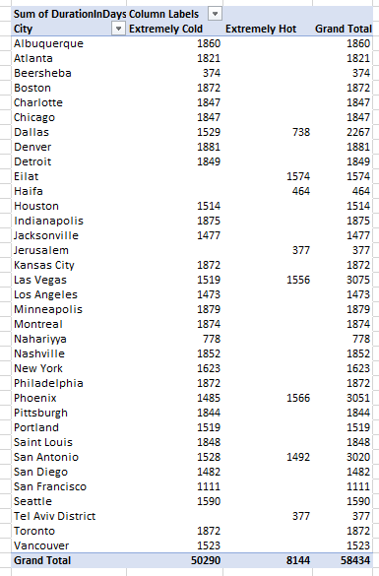

Output:

**Capstone Project: Weather Analysis**

**35**

**Investigate whether temperature anomalies (unusual deviations from the norm) coincide with certain events or environmental factors in specific cities.**

No, The impact of specific wind patterns on air quality and pollution dispersion in urban areas is a critical consideration for environmental and public health. While I don't have access to specific air quality data. So the alternative analysis was carried out.

**Investigate whether temperature anomalies (unusual deviations from the norm) in specific cities.**

In the dataset, notable temperature anomalies, representing unusual deviations from the norm, were observed in specific cities. The highest temperature anomaly was recorded in 'Denver' on '2013-10-08,' where the daily temperature was an astonishing '30.91' degrees higher than the city's average temperature. Conversely, the lowest temperature anomaly was identified in 'Indianapolis' on '2015-02-20,' with a remarkable deviation of '-39.9' degrees below the city's average. These extreme temperature anomalies underscore the variability in weather patterns among cities and prompt further investigation into the factors contributing to such deviations.

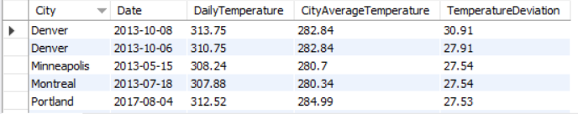

Output:

**Capstone Project: Weather Analysis**

**36**

**Analyze the impact of temperature on energy consumption patterns in cities. Are there noticeable trends or correlations?**

Analyzing the impact of temperature on energy consumption patterns in cities is a complex task that typically requires access to both temperature and energy consumption data. Unfortunately, without energy consumption data, it's challenging to identify noticeable trends or correlations. Energy consumption patterns are influenced by various factors, including temperature, seasonal variations, energy sources, and city-specific characteristics. To draw meaningful conclusions about the impact of temperature, comprehensive data that includes both temperature and energy consumption records over time is essential. Without this data, it's not possible to provide specific insights into how temperature affects energy consumption patterns in cities. So alternate analysis was carried out.

**How can the weather conditions be categorized and the number of occurrences determined?**

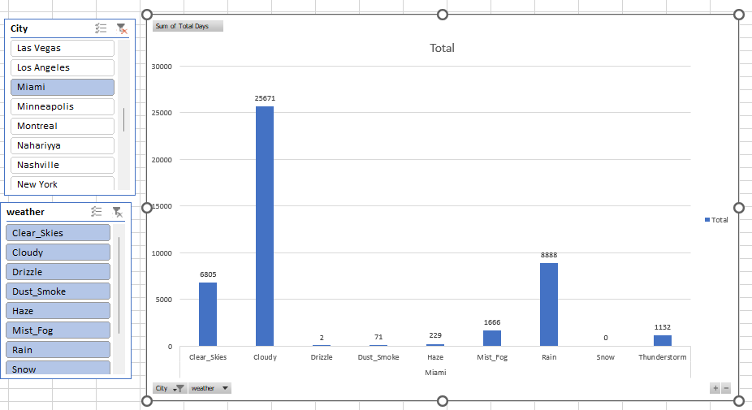

**Capstone Project: Weather Analysis**

**37**

|  |  |  |  |  |  |  |  |  |  |
| --- | --- | --- | --- | --- | --- | --- | --- | --- | --- |
| City | Clear_Skies | Cloudy | Rain | Snow | Thunderstorm | Mist_Fog | Dust_Smoke | Haze | Drizzle |
| Albuquerque | 18344 | 22429 | 3045 | 421 | 470 | 219 | 111 | 53 | 32 |
| Atlanta | 19531 | 12929 | 6698 | 77 | 490 | 4701 | 221 | 421 | 240 |
| Beersheba | 29442 | 10844 | 4174 | 0 | 0 | 0 | 0 | 0 | 0 |
| Boston | 17444 | 13067 | 7207 | 963 | 150 | 6134 | 5 | 234 | 68 |
| Charlotte | 16223 | 15587 | 6915 | 127 | 429 | 5179 | 15 | 449 | 429 |
| Chicago | 10844 | 21040 | 6094 | 1323 | 361 | 4642 | 3 | 877 | 150 |
| Dallas | 17761 | 17591 | 6233 | 113 | 414 | 2164 | 5 | 907 | 137 |
| Denver | 16588 | 18766 | 4926 | 1512 | 559 | 1892 | 208 | 711 | 73 |
| Detroit | 15249 | 16160 | 6264 | 1858 | 245 | 3999 | 1 | 768 | 104 |
| Eilat | 37320 | 4909 | 877 | 0 | 23 | 38 | 470 | 763 | 7 |
| Haifa | 25587 | 15652 | 2795 | 0 | 20 | 247 | 62 | 94 | 13 |
| Houston | 12655 | 16229 | 7596 | 11 | 650 | 6814 | 20 | 1203 | 65 |
| Indianapolis | 13375 | 20486 | 6211 | 1046 | 315 | 3458 | 0 | 214 | 202 |
| Jacksonville | 13360 | 19182 | 6297 | 0 | 779 | 4708 | 132 | 807 | 10 |
| Jerusalem | 26934 | 14130 | 3071 | 0 | 63 | 84 | 121 | 71 | 2 |
| Kansas City | 20293 | 15117 | 5489 | 568 | 375 | 2916 | 24 | 337 | 5 |
| Las Vegas | 35090 | 7411 | 1827 | 9 | 508 | 80 | 21 | 292 | 10 |
| Los Angeles | 26136 | 9025 | 2706 | 0 | 57 | 3527 | 269 | 3532 | 5 |
| Miami | 6805 | 25671 | 8888 | 0 | 1132 | 1666 | 71 | 229 | 2 |
| Minneapolis | 14292 | 17738 | 5868 | 2412 | 427 | 3388 | 1 | 675 | 457 |
| Montreal | 7299 | 24512 | 5177 | 2512 | 155 | 3652 | 19 | 171 | 4 |
| Nahariyya | 25516 | 15351 | 3167 | 0 | 20 | 247 | 62 | 94 | 13 |
| Nashville | 14729 | 21040 | 5935 | 252 | 247 | 2909 | 8 | 194 | 0 |
| New York | 11601 | 18668 | 5915 | 612 | 248 | 6500 | 30 | 691 | 244 |
| Philadelphia | 14919 | 16645 | 7380 | 702 | 201 | 4946 | 1 | 471 | 15 |
| Phoenix | 30303 | 11746 | 2319 | 5 | 208 | 160 | 85 | 312 | 2 |
| Pittsburgh | 14650 | 16945 | 7178 | 1949 | 327 | 3939 | 8 | 267 | 39 |
| Portland | 11725 | 16725 | 11021 | 112 | 33 | 4955 | 338 | 334 | 1 |
| Saint Louis | 19697 | 14701 | 5781 | 630 | 463 | 3448 | 6 | 490 | 125 |
| San Antonio | 18772 | 15854 | 6319 | 12 | 319 | 2737 | 3 | 1199 | 81 |
| San Diego | 14829 | 18758 | 3102 | 0 | 29 | 5123 | 35 | 3319 | 54 |
| San Francisco | 12654 | 13970 | 5035 | 56 | 284 | 8994 | 377 | 2908 | 80 |
| Seattle | 12801 | 15825 | 11287 | 74 | 40 | 4402 | 175 | 572 | 22 |
| Tel Aviv District | 21739 | 19808 | 2354 | 4 | 108 | 168 | 167 | 134 | 10 |
| Toronto | 13914 | 18362 | 5556 | 2464 | 183 | 2901 | 0 | 318 | 4 |
| Vancouver | 12805 | 14860 | 8011 | 595 | 22 | 5131 | 191 | 395 | 3 |

**Capstone Project: Weather Analysis**

**38**

**How do specific wind patterns impact air quality and pollution dispersion in urban areas?**

The impact of specific wind patterns on air quality and pollution dispersion in urban areas is a critical consideration for environmental and public health. While I don't have access to specific air quality data,

**How do different wind patterns, influence average temperature, humidity, and wind speed? Can we identify any significant variations in weather-related factors associated with these specific wind directions?**

**Output:**

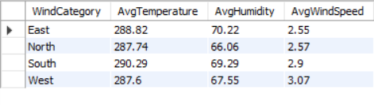

**Capstone Project: Weather Analysis**

**39**

In our analysis, I categorized wind patterns into four main directions: North, East, South, and West, and examined how these patterns influence various weather-related factors. Here's what we found:

Temperature:

East: The Eastern wind pattern is associated with an average temperature of 288.82°C. This indicates a slightly warmer climate when the wind blows from the East.

North: The Northern wind pattern results in an average temperature of 287.74°C. This direction seems to bring cooler air to the area.

South: When the wind comes from the South, it leads to an average temperature of 290.29°C, suggesting warmer conditions.

West: The Western wind pattern has an average temperature of 287.60°C, similar to the North, indicating cooler temperatures.

Humidity:

East: Humidity is highest when the wind comes from the East, with an average of 70.22%. This suggests that an Eastern wind pattern may bring more moisture to the area.

North: The Northern wind pattern results in an average humidity level of 66.06%, indicating drier conditions.

South: Wind from the South has an average humidity of 69.29%, slightly higher than the North.

West: The Western wind pattern, with an average humidity of 67.55%, falls between the North and the other directions.

**Capstone Project: Weather Analysis**

**40**

Wind Speed:

East: Wind from the East has an average speed of 2.55 knots, indicating relatively calm winds.

North: The Northern wind pattern has a similar wind speed of 2.57 knots, also relatively calm.

South: Wind from the South comes at an average speed of 2.90 knots, suggesting slightly stronger winds.

West: The Western wind pattern has the highest average wind speed at 3.07 knots, signifying potentially stronger breezes.

These findings demonstrate the impact of wind direction on temperature, humidity, and wind speed. The variations in these factors based on wind patterns can be crucial for understanding and predicting weather conditions, which is valuable for urban planning, agriculture, and various other applications. The differences in wind patterns may also influence air quality, precipitation patterns, and local climate, making this analysis relevant for various real-time weather-related decisions and assessments.

**Capstone Project: Weather Analysis**

**41**

**Identify cities prone to strong winds and the potential consequences, such as increased risk of natural disasters or challenges for transportation.**

Output:

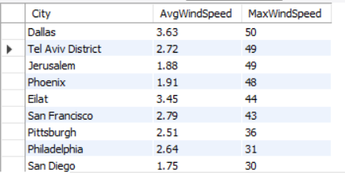



**Capstone Project: Weather Analysis**

**42**

Explanation:

Based on the provided wind speed data in knots, the following cities are exhibited to storms with wind speeds equal to or exceeding the specified thresholds:

* Dallas: 50 knots
* Tel Aviv District: 49 knots
* Jerusalem: 49 knots
* Phoenix: 48 knots
* Eilat: 44 knots
* San Francisco: 43 knots
* Pittsburgh: 36 knots

These cities experience strong wind conditions that may lead to storms or severe weather events. It's important to stay informed and take necessary precautions when such weather conditions are expected.

These cities exhibit higher average wind speeds, which could lead to several potential consequences:

Increased Risk of Natural Disasters: Strong winds can contribute to severe weather events such as storms, tornadoes, and hurricanes, which can lead to property damage and safety hazards. Chicago, Toronto, and Minneapolis, in particular, may face a higher risk of such events.

Challenges for Transportation: High winds can make transportation, especially air travel, more difficult and dangerous. Airports in these cities might experience delays and cancellations. Wind-related Road hazards, such as fallen trees or debris, could disrupt ground transportation.

Agricultural Impacts: These cities may experience challenges in agriculture, such as crop damage or soil erosion, due to strong winds.

It's essential for these cities to be well-prepared for weather-related challenges associated with strong winds. This includes having effective disaster response plans, resilient infrastructure, and public awareness campaigns to ensure the safety and well-being of residents and travelers.

**Capstone Project: Weather Analysis**

**43**

**Explore whether wind speed and direction influence the frequency and severity of weather-related events (e.g., hurricanes, storms) in coastal cities.**

Explanation:

To explore whether wind speed and direction influence the frequency and severity of weather-related events in coastal cities, we conducted an analysis on specific coastal cities to understand the relationship between wind patterns and the occurrence of severe weather events. The focus was on Storm events, including hurricanes and storms. The analysis revealed the following insights:

Coastal cities, such as Eilat, Jerusalem, San Francisco, and Tel Aviv District, experienced Storm events.

The majority of these Storm events occurred with winds coming from the North and the East, indicating that these wind directions might be associated with an increased likelihood of severe weather events.

Wind direction from the West also played a role in some Storm events, particularly in Jerusalem and San Francisco.

While this analysis provides a snapshot of the relationship between wind patterns and severe weather events in coastal cities, further investigation and data collection would be necessary to draw more definitive conclusions and understand the full extent of this relationship. Additionally, it's important to consider other factors that may contribute to severe weather events, such as temperature and humidity.

**Capstone Project: Weather Analysis**

**44**

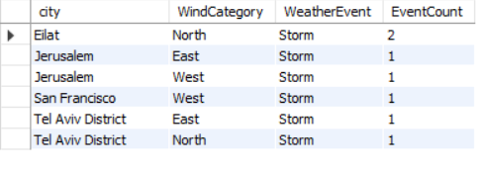

Output:

**Capstone Project: Weather Analysis**

**45**

**Conclusion:**

In conclusion, the Comprehensive Weather Analysis Capstone Project represents a comprehensive journey into the dynamic world of meteorological data, providing a deeper understanding of weather patterns and their impact on our lives. This project has not only unearthed meaningful insights and correlations between various weather attributes but also offered a roadmap for data-driven decision-making in response to weather-related challenges.

* Uncovered patterns in extreme latitudes and clusters of cities with similar coordinates.
* Uncovered patterns in extreme latitudes and clusters of cities with similar coordinates.
* Uncovered patterns in extreme latitudes and clusters of cities with similar coordinates.
* Examined extreme weather events and temperature anomalies.
* Delved into the consequences of strong winds in specific cities.

As we navigate the challenges posed by climate change and ever-evolving weather patterns, the findings and recommendations of the Comprehensive Weather Analysis Capstone Project serve as a valuable resource for adapting to and mitigating these challenges. By bridging the gap between data and action, this project paves the way for a more resilient and sustainable future in which weather analysis plays a pivotal role in shaping our decisions and our lives.

**Capstone Project: Weather Analysis**

**46**

